Cowboys of Code

EMS-PSS Project

Progress Report 2

Project Points Breakdown

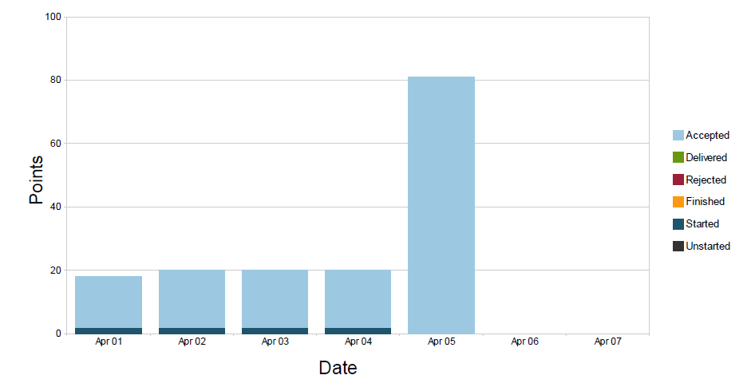

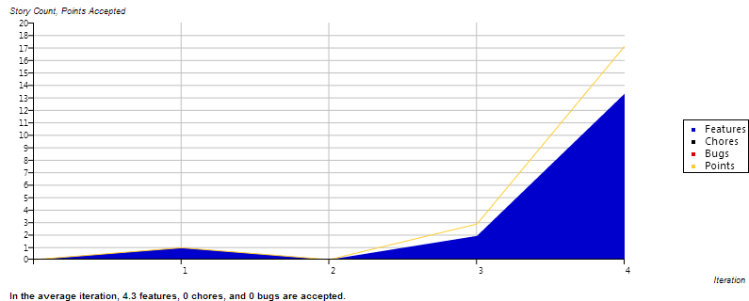Current Iteration Burn Up chart

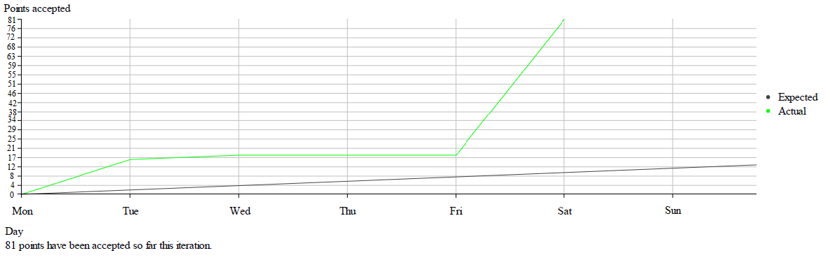

Story Type Breakdown

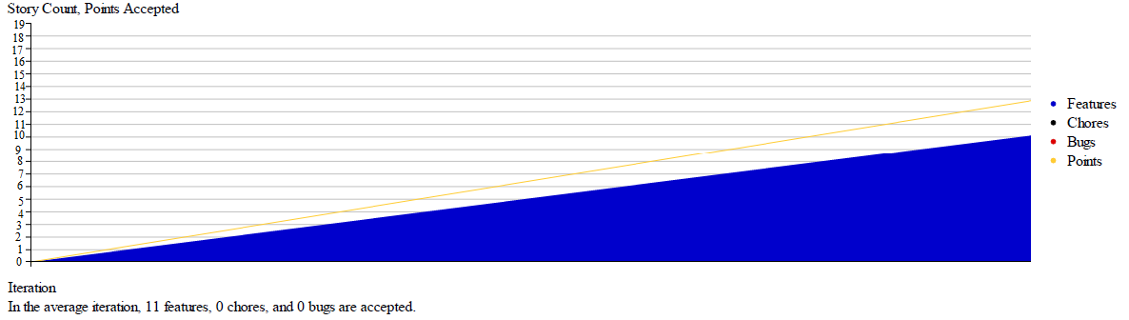

**Analysis:**

Despite our charts looking a little off we still managed to finish the EMS-PSS way ahead of schedule. The reason it appears that we did very little in these charts up until the last iteration was because we were slow to start coding and once we did start over the last couple days we forgot to start, deliver, and accept stories on Pivotal Tracker. Another issue we had is that certain stories were hard for us to say were completed or not just because of the way MVC works. Despite all we have still finished the EMS-PSS ahead of schedule and all that’s left is to demo the project.